How to login the homepage of this range extender
Product line: Wireless Model number: A300/A301
This article will guide you how to login the homepage of range extender. If you have already set A300 in extender mode successfully, you must connect PC to A300 with Ethernet cable to login its homepage.
Steps are as follow.
Part 1: Connect the devices
Part 2: Configure your computer
Part 3: Login the range extender

1 Position the wireless range extender close to a wireless router or access point and then plug it into a
power outlet nearby.

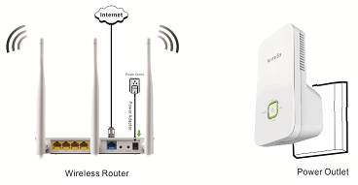

2 Connect your Wireless Clients (such as notebook, pad, smart phone, etc.) to the range extender wirelessly. Or
connect your PC to the sole LAN port of Range Extender with an Ethernet cable.

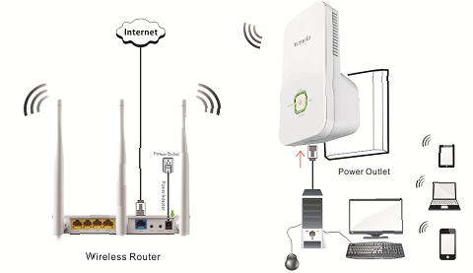

Note: after connection the LAN light should be blinking.
1 Click on Network Connection Icon on the system bar, then click on Open Network and Sharing Center. (Here is for windows 7, other operating system please click HERE.)
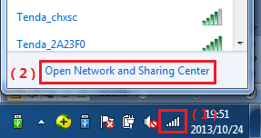
2 Click on Change adapter settings.
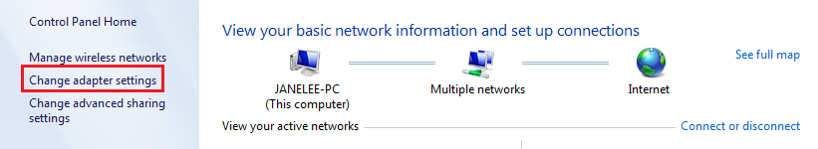
3 Right click on Local Area Connection, then choose Properties option.
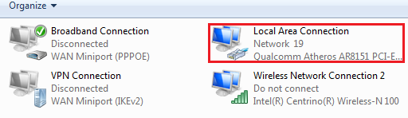
4 Double click on Internet Protocol Version 4(TCP/IPv4)
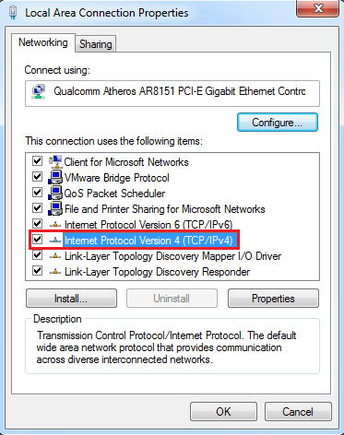
5 Choose Obtain an IP address automatically and Obtain DNS server address automatically and then click OK.
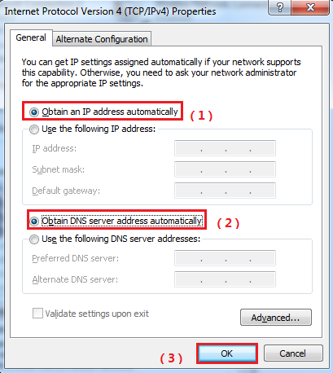
6 Also click on OK on the first Local Connection Properties window
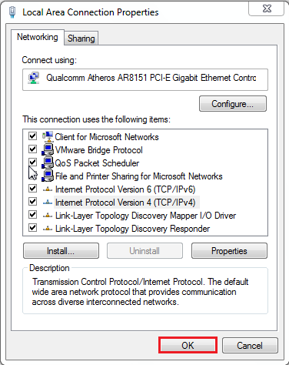

1 Open a browser then type re.tendacn.com in the Address bar, click Enter.
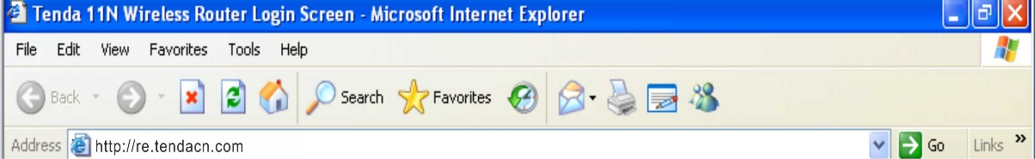
Note: if you cannot login the management page, please click HERE.
2 Type the Password in the bars then click on the Login button to login the setting page.
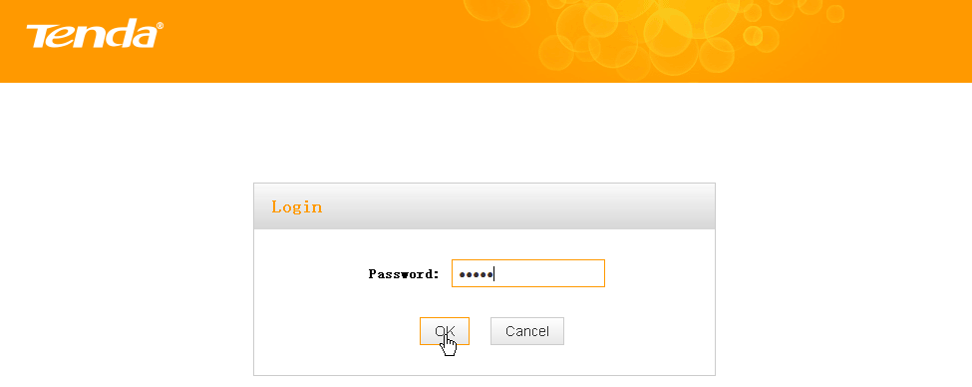

If you still can’t login the management page of A300 with re.tendacn.com after setting A300
in extender mode，please login upper router to check the IP assigned to A300.
For example, we can find the client list of upper router as follow: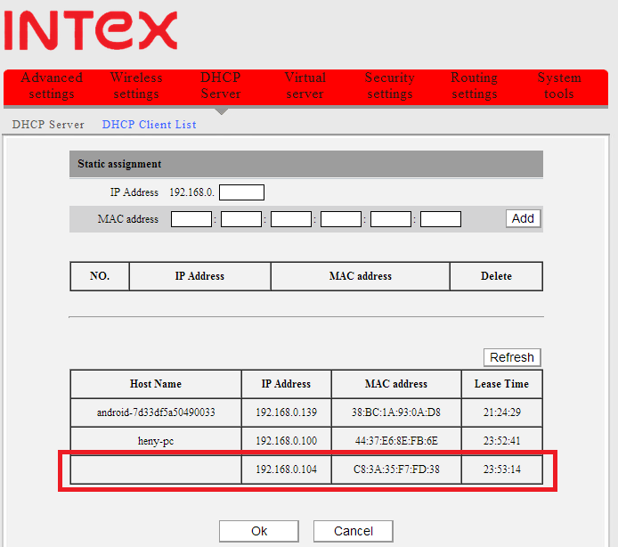

The IP address of A300 assigned by upper router is 192.168.0.104 ，then we can also login A300 with 192.168.0.104
